**SQL19D-Comprehensive Database Implementation and Optimization**

**Were Vincent Ouma**

**12/6/2024**

**SQL19D-Comprehensive Database Implementation and Optimization**

**Step 1: Install SQL Server 2019 Instance**

1. **Login**

* Installed SQL Server 2019 on a Windows Server machine and login.
* Chose appropriate service accounts during installation.

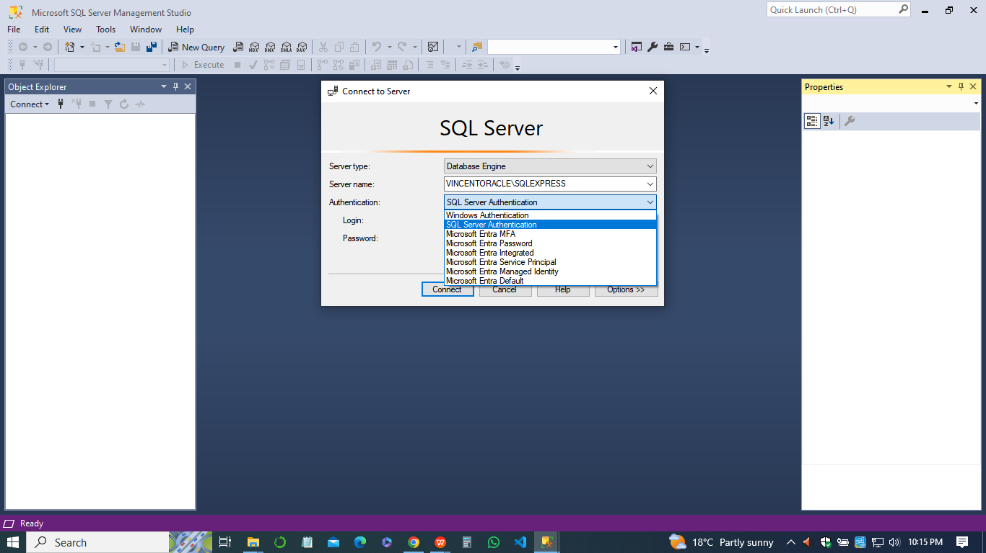

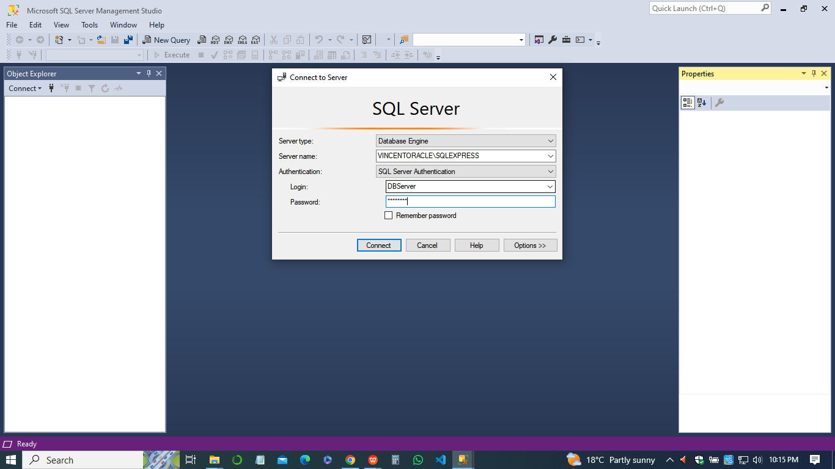

1. **Enable remote SQL TCP connections**

* Enabled remote SQL TCP connections in SQL Server Configuration Manager.

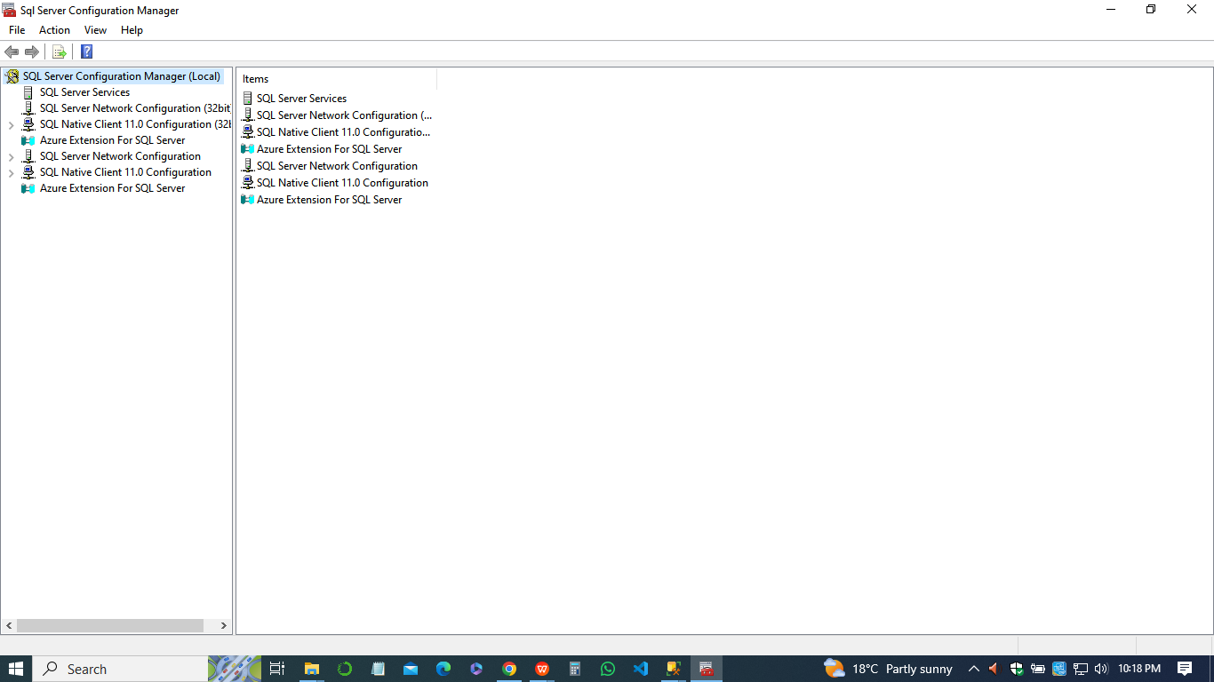

* Completed the installation process and verified that SQL Server was running correctly.

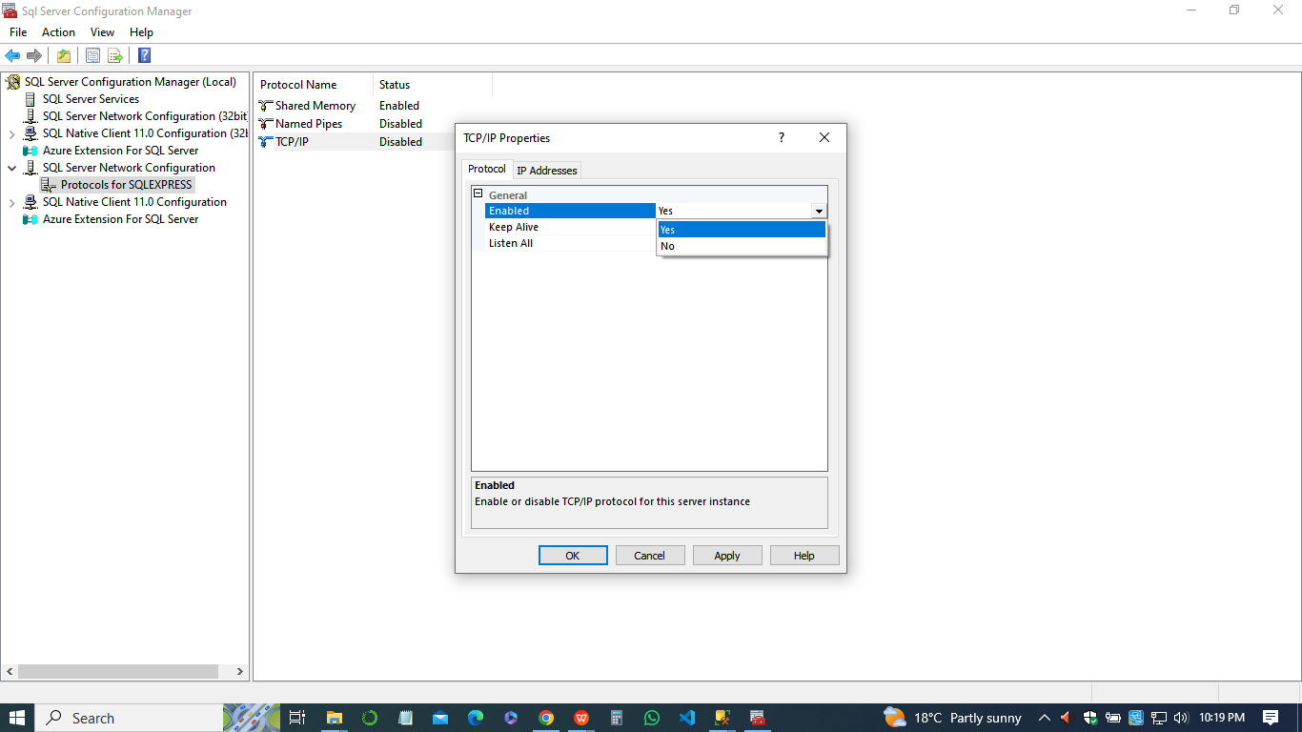

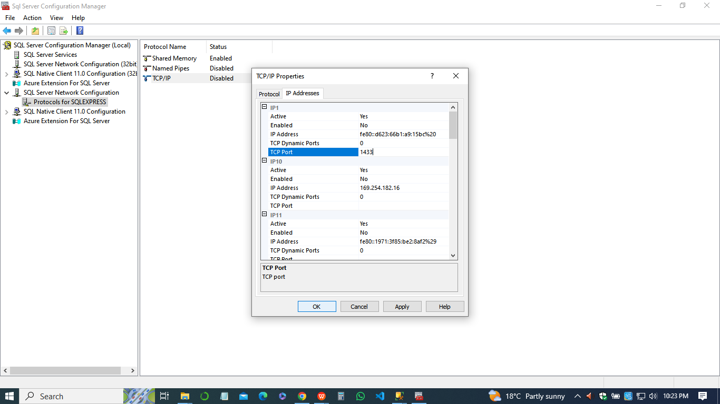

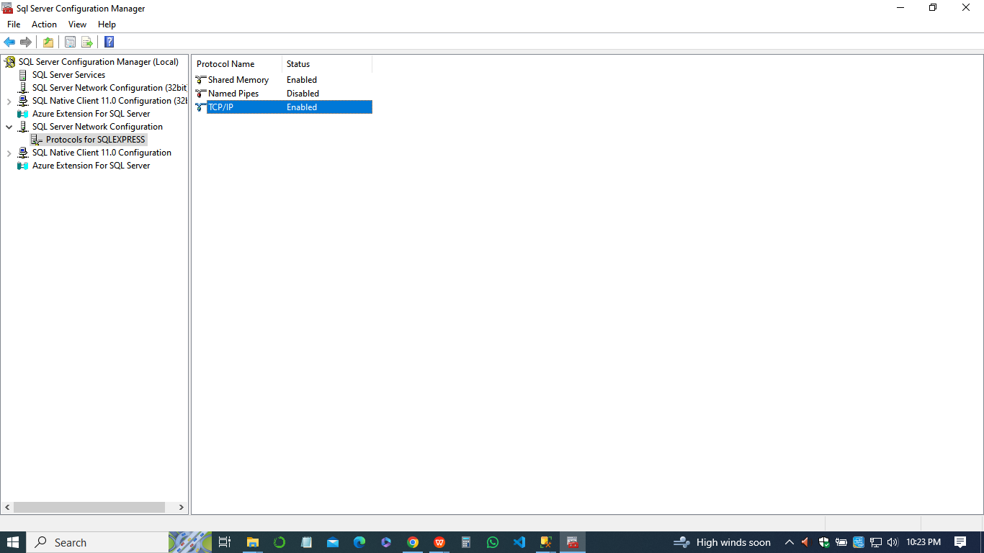

1. **Ensuring that all SQL necessary SQL Server services are set to start automatically and accept secure network connections.**

* Configured SQL Server to accept secure network connections.
* Ensured that all necessary SQL Server services were set to start automatically. *10 marks*

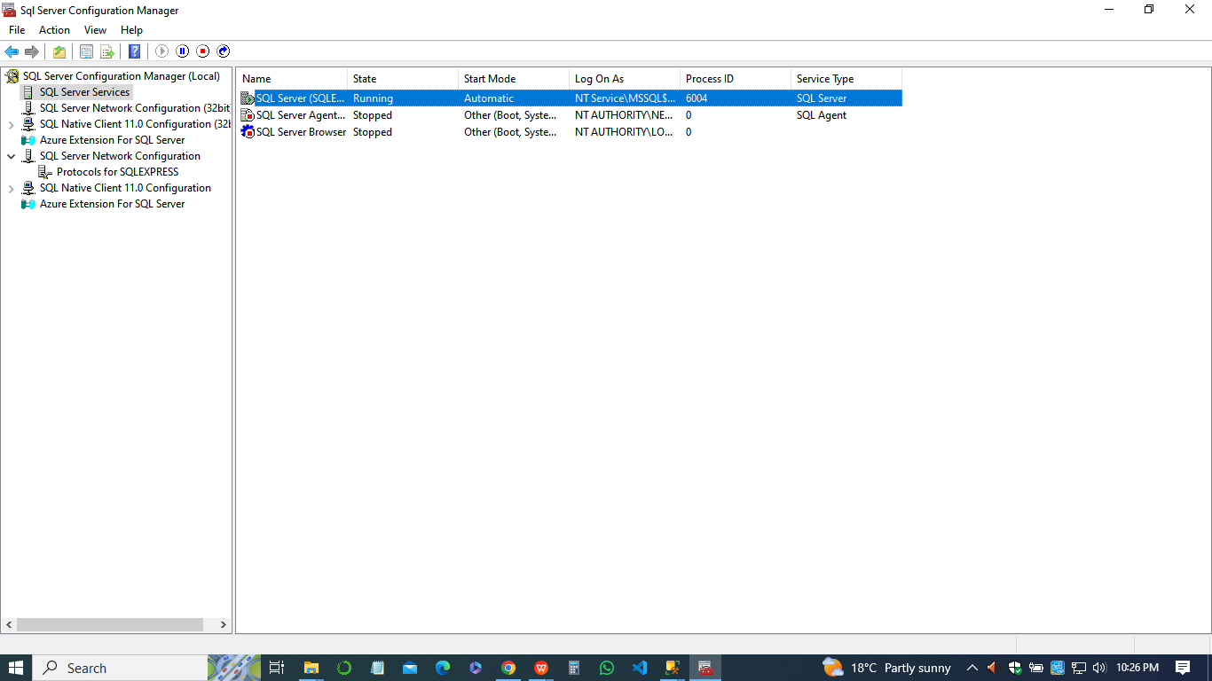

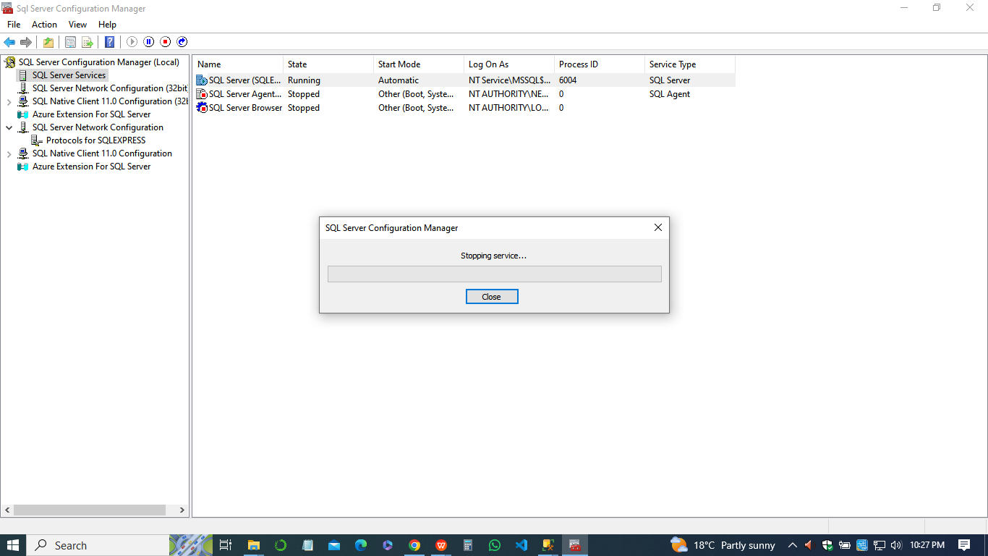

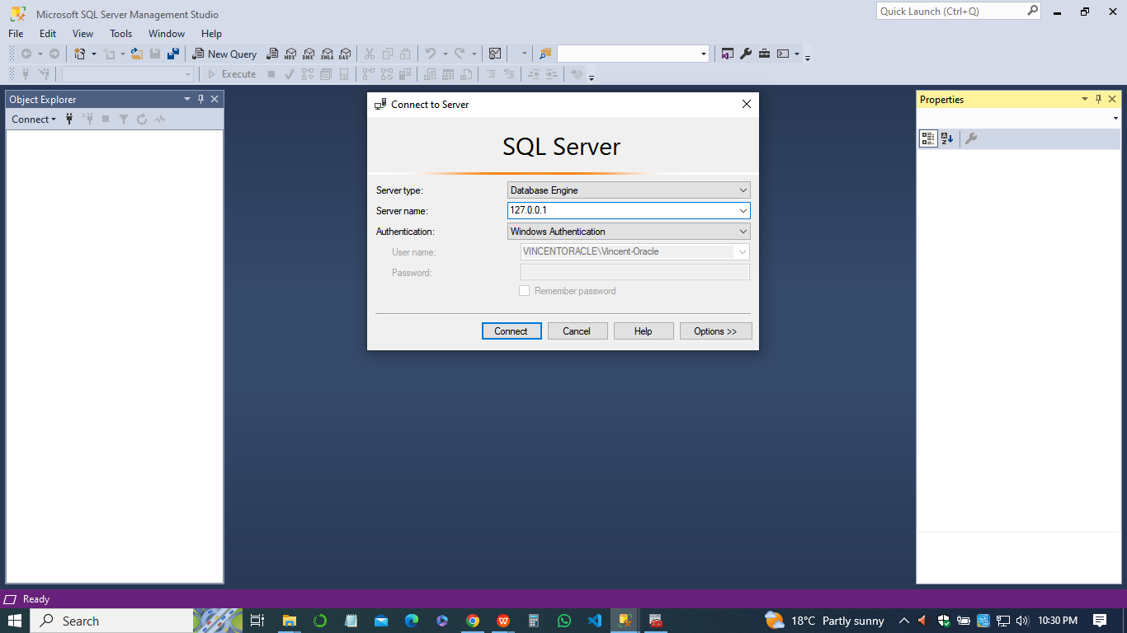

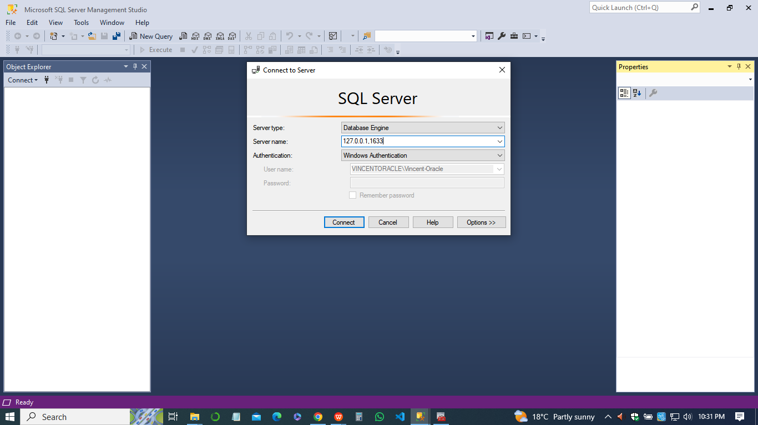

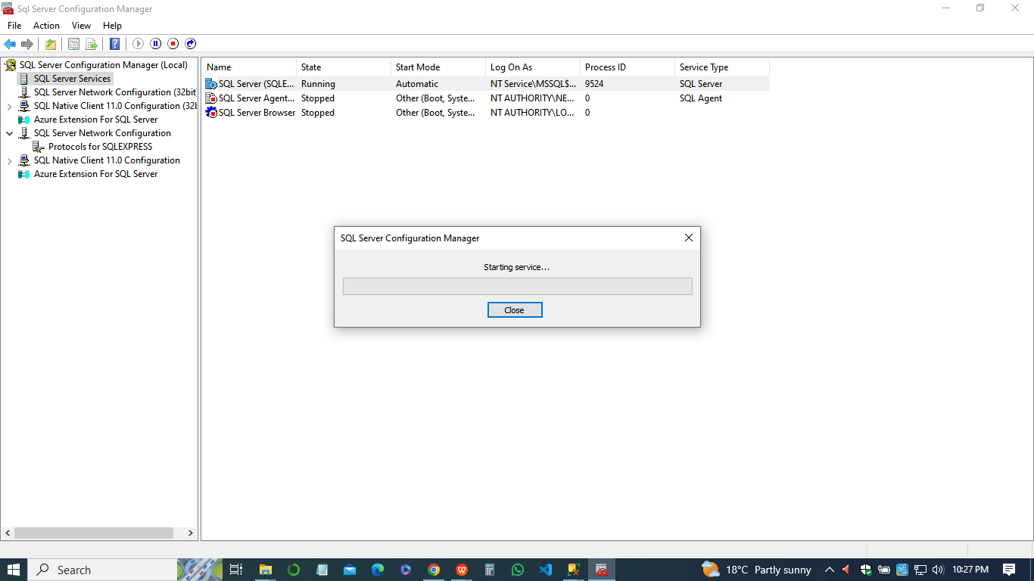

**Step 2: Database Design**

1. Designed a database for an IT Consulting Company providing services and equipment.
2. Identified entities such as Clients, Services, EquipmentTypes, Equipment, Transactions, Purchases, and Resales.
3. Created entity-relationship diagrams (ERD) to visualize table relationships.
4. Defined table structures including columns, data types, constraints, and relationships.
5. Ensured normalization and appropriate data integrity constraints.
6. Documented the database design process for future reference.
7. **Tables**
8. ***Clients***

* Stores information about client organizations.
* Columns: ClientID (Primary Key), Name, ContactInfo

1. ***Services***

* Contains details of services provided by the IT consulting company.
* Columns: ServiceID (Primary Key), Description, Price

1. ***EquipmentTypes***

* Describes different types of equipment available.
* Columns: TypeID (Primary Key), TypeName

1. ***Equipment***

* Records information about the equipment being sold or purchased.
* Columns: EquipmentID (Primary Key), TypeID (Foreign Key), Description

1. ***Transactions***

* Tracks transactions made by clients.
* Columns: TransactionID (Primary Key), ClientID (Foreign Key), ServiceID (Foreign Key), Quantity, TotalPrice, Date

1. ***Purchases***

* Logs equipment purchases made by the company.
* Columns: PurchaseID (Primary Key), EquipmentID (Foreign Key), Date, Price

1. ***Resales***

* Records equipment resales to clients.
* Columns: ResaleID (Primary Key), ClientID (Foreign Key), EquipmentID, Date and price.

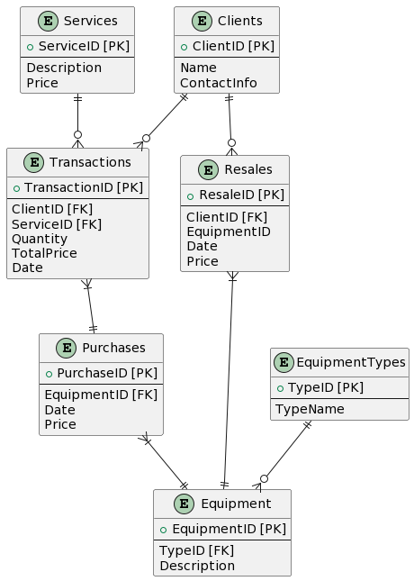

1. **Relationships**
2. Clients has a one-to-many relationship with Transactions and Resales tables.
3. Services has a one-to-many relationship with Transactions table.
4. EquipmentTypes has a one-to-many relationship with Equipment table.
5. Transactions and Purchases tables are related through the EquipmentID column.
6. Transactions and Services tables are related through the ServiceID column.
7. Resales and Equipment tables are related through the EquipmentID column.
8. Purchases and Equipment tables are related through the EquipmentID column.

This ER diagramabove, provides a clear representation of the database structure for the IT Consulting Company, including tables, columns/datatypes, and table relationships. It forms the foundation for creating the database schema in SQL Server 2019.

**Step 3: Create Database and Tables**

1. Created a new database named "ITConsultingDB" in SQL Server Management Studio.
2. Executed SQL scripts to create tables for each entity identified in the database design phase.
3. Ensured that each table was created with appropriate columns, data types, primary keys, foreign keys, and constraints.
4. Verified the successful creation of tables by querying the system catalogs.
5. ***Create Database***

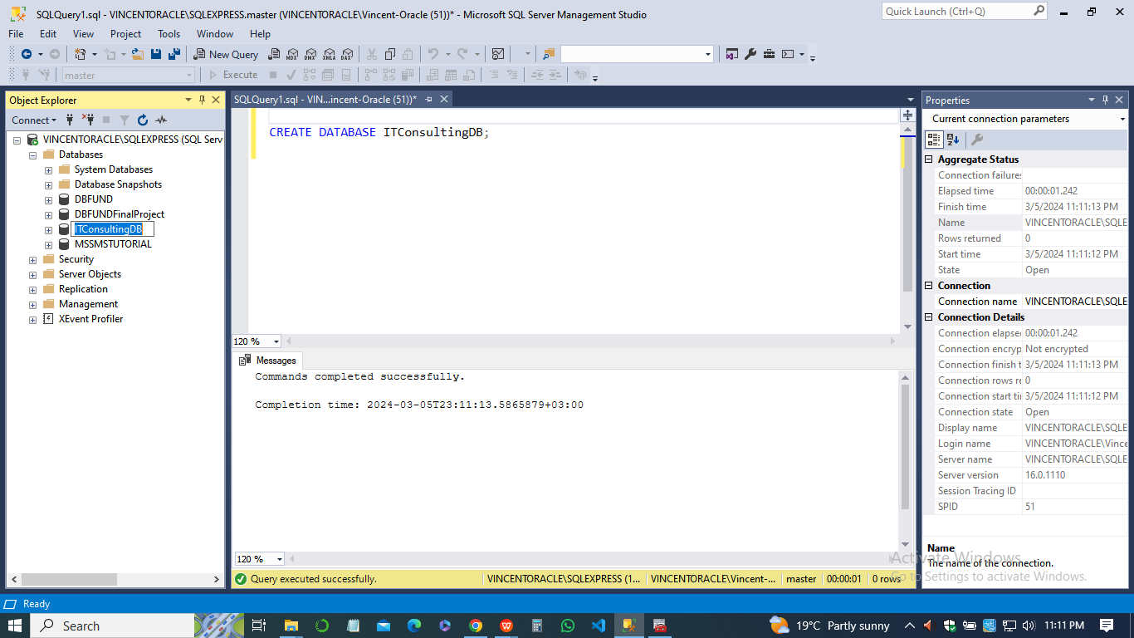

1. ***Create Tables***

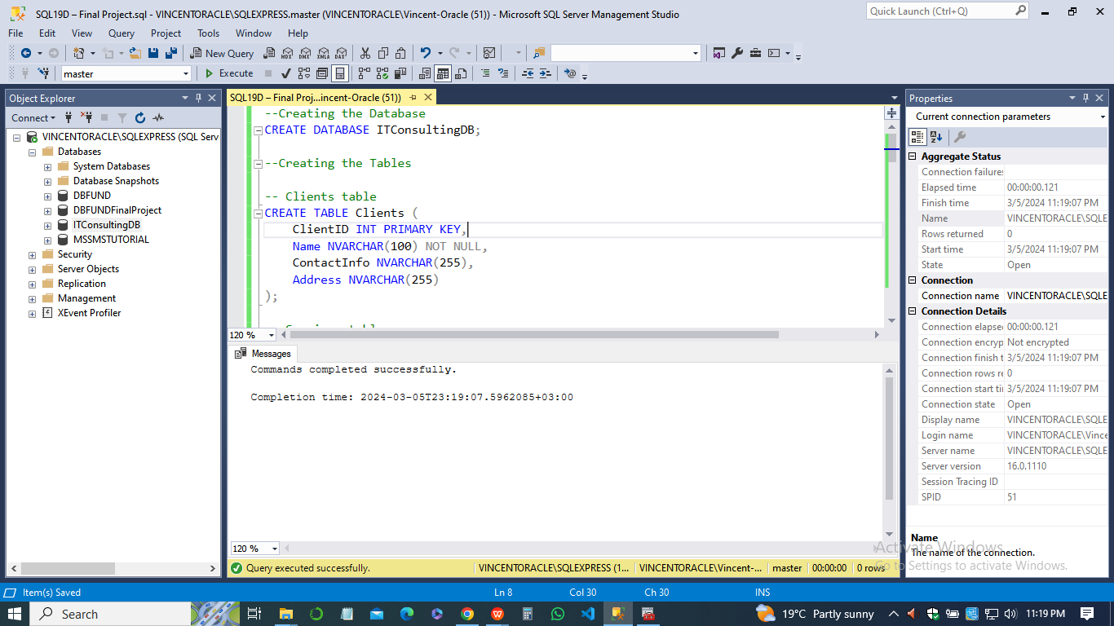

1. ***Populate Tables with atleast 50 records***
2. *Clients*

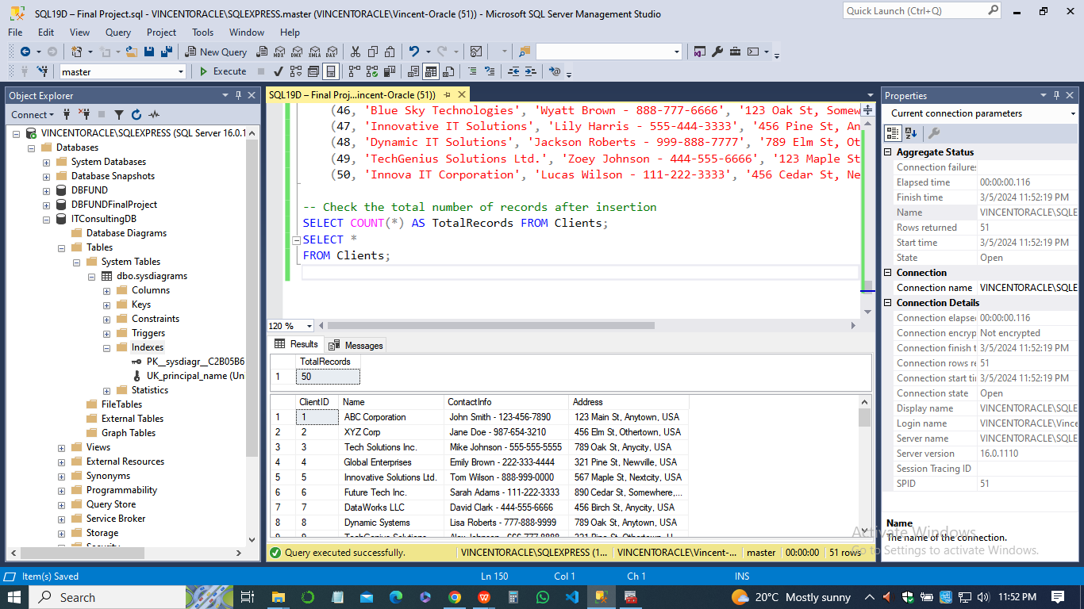

1. *Services*

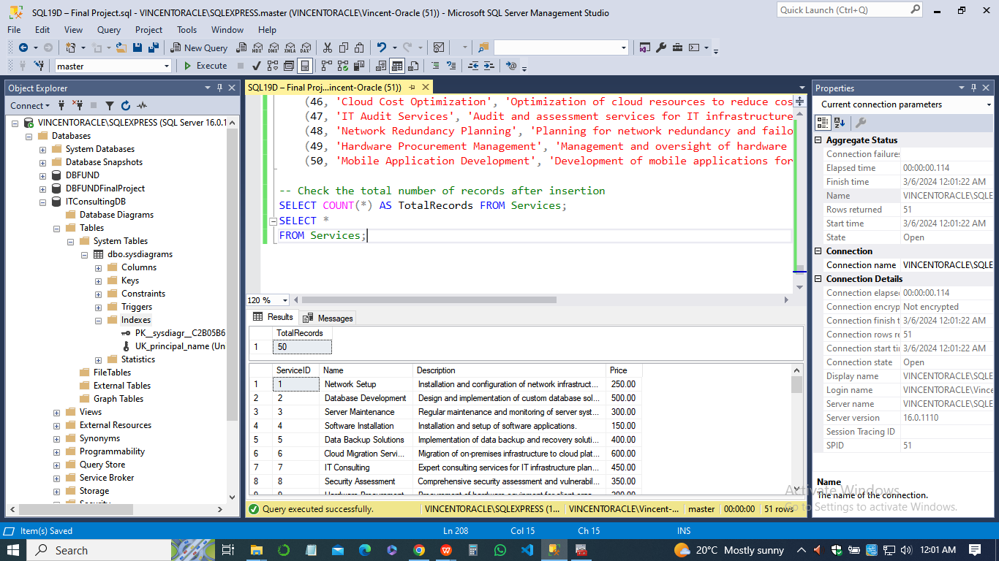

1. *EquipmentTypes*

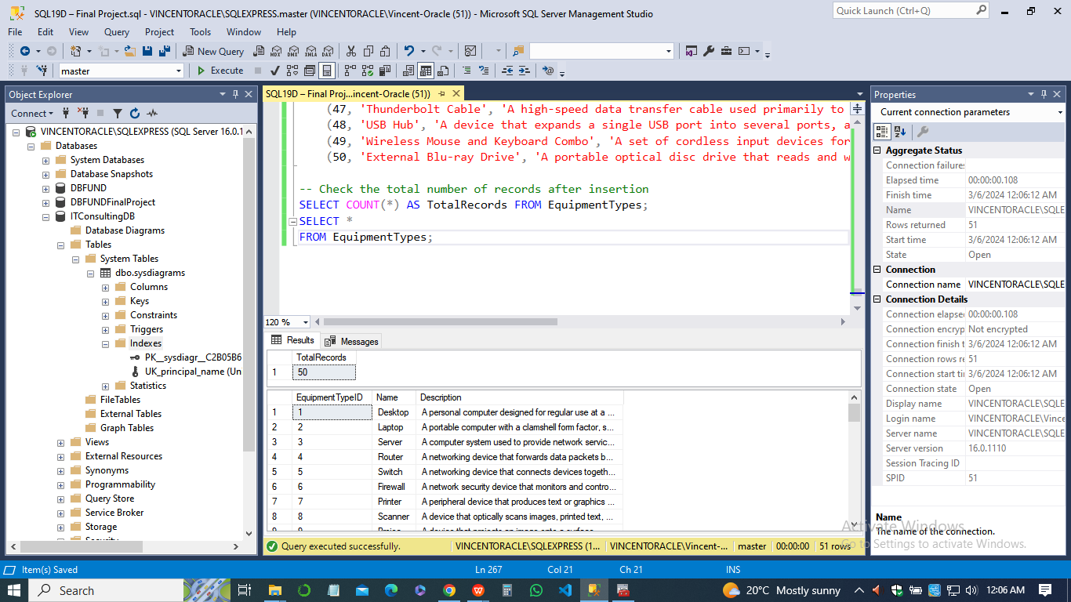

1. *Equipment*

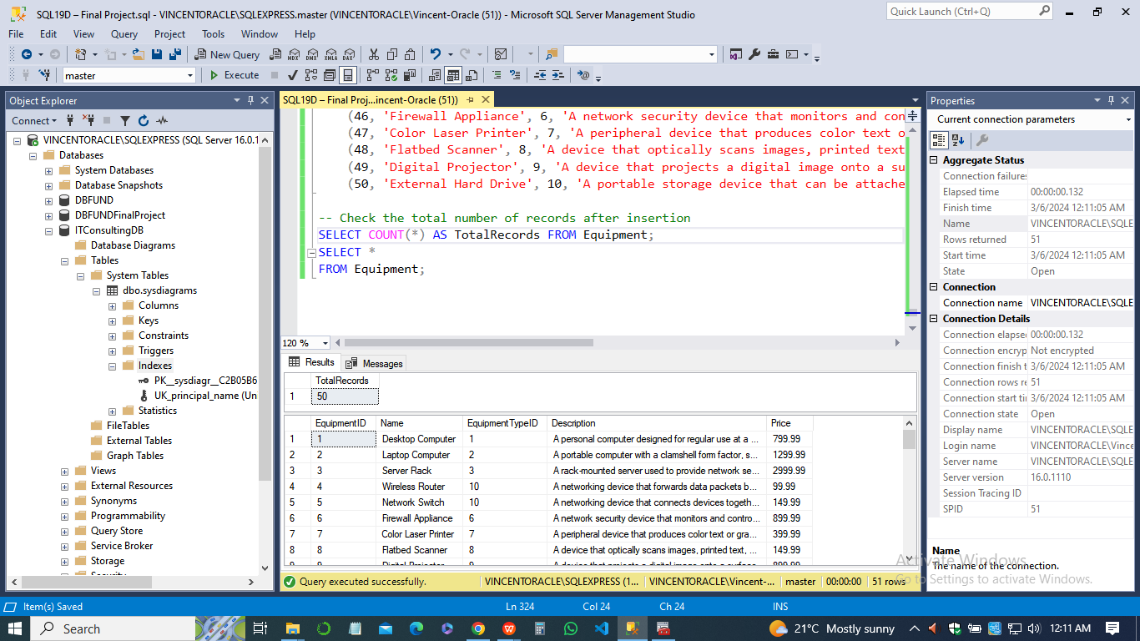

1. *Transactions*

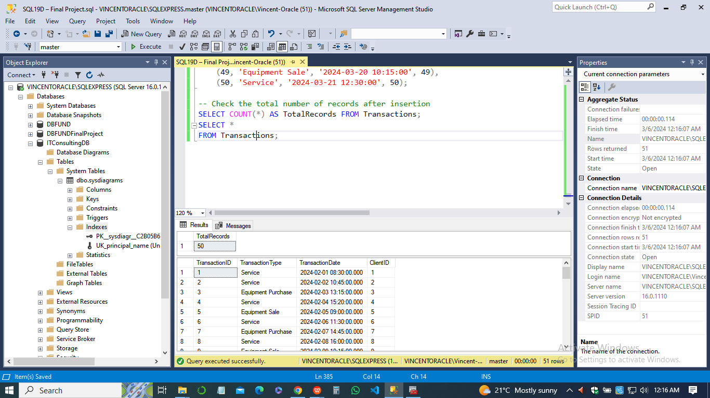

1. *Purchases*

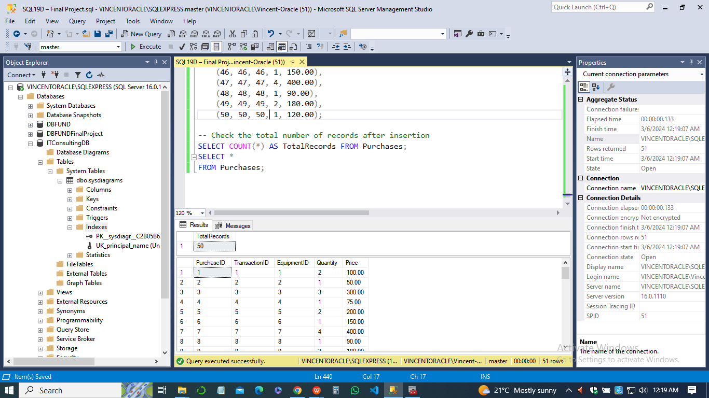

1. *Resales.*

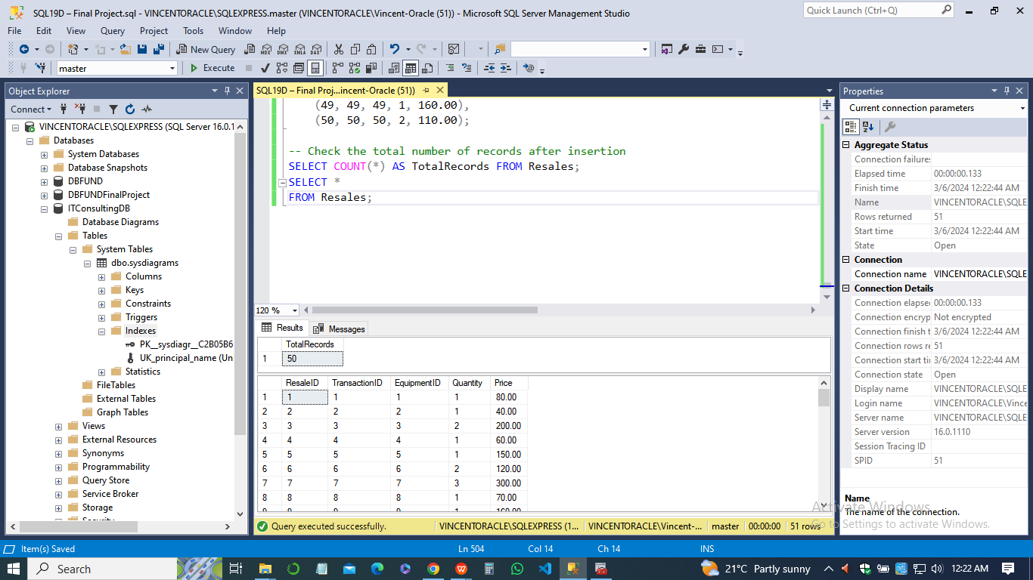

1. ***Create Indexes***

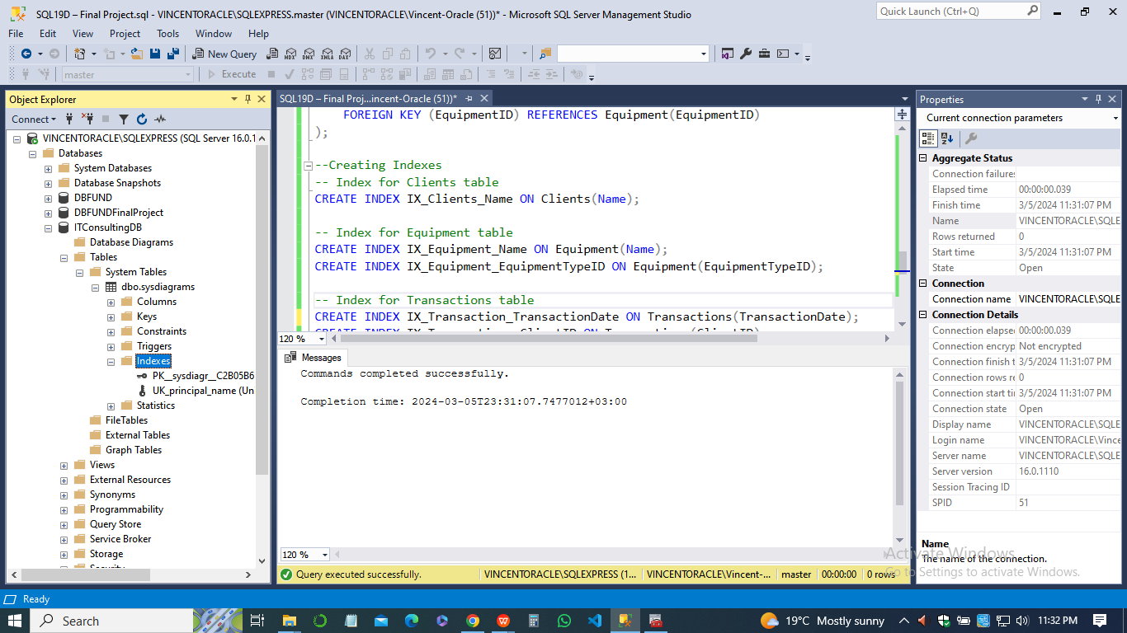

1. ***Database options***

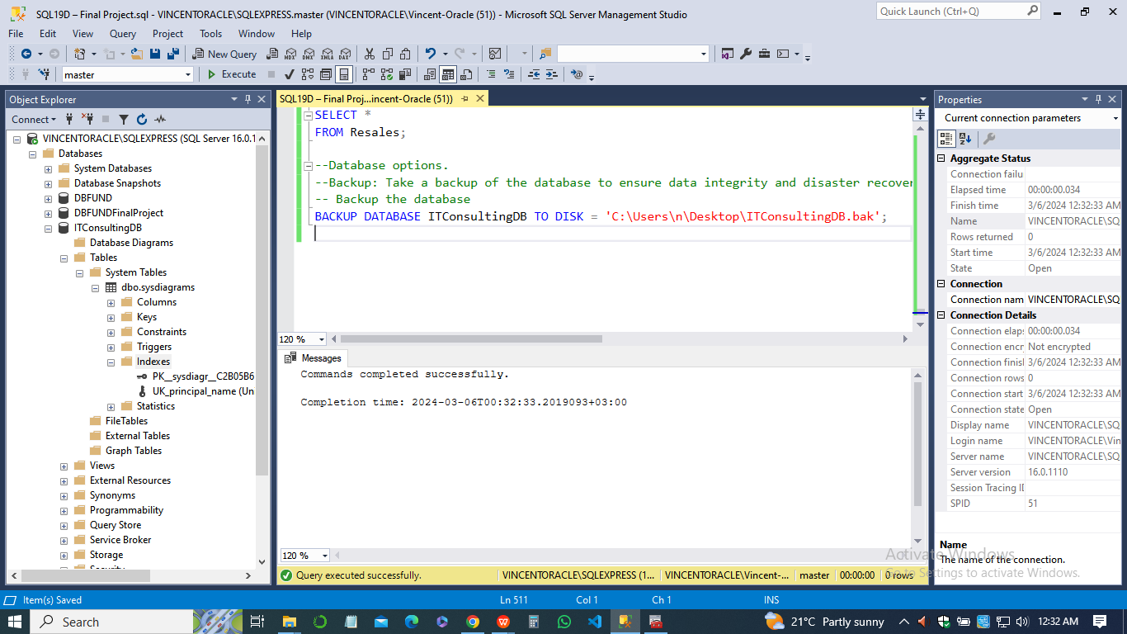

This command will create a full backup of the database and store it at the specified location ('C:\Users\n\Desktop\ITConsultingDB.bak';).

**Step 4: SQL Logins and Users**

1. Created SQL logins for accessing the database.
2. Created a SQL login with permissions to access and modify records within the database.
3. Created another SQL login with read-only permissions to access records within the database.
4. Created a SQL login for the application developer within the organization.
5. Associated each SQL login with a corresponding user in the database.
6. ***Create a SQL login with permissions to access and modify records***

CREATE LOGIN KaylaMcFarlane1 WITH PASSWORD = '@KaylaMcFarlane1';

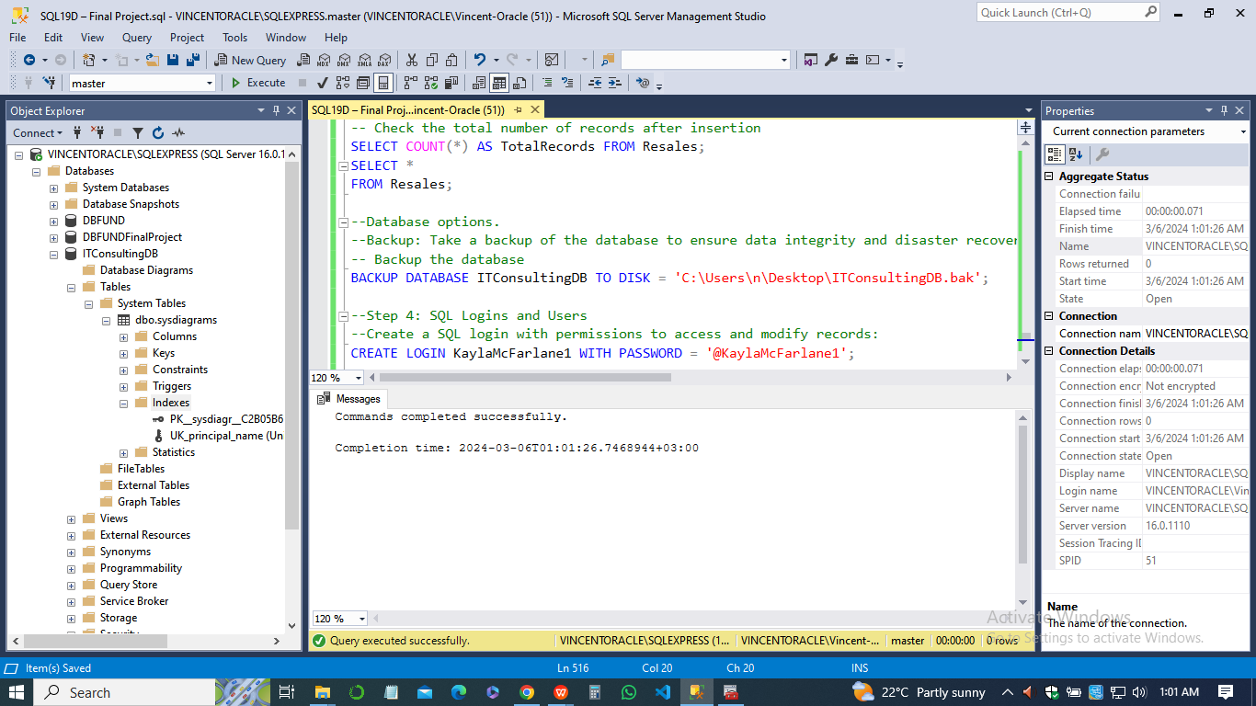

1. ***Create a user in the database associated with the login***

USE ITConsultingDB;

CREATE USER KaylaMcFarlane1 FOR LOGIN KaylaMcFarlane1;

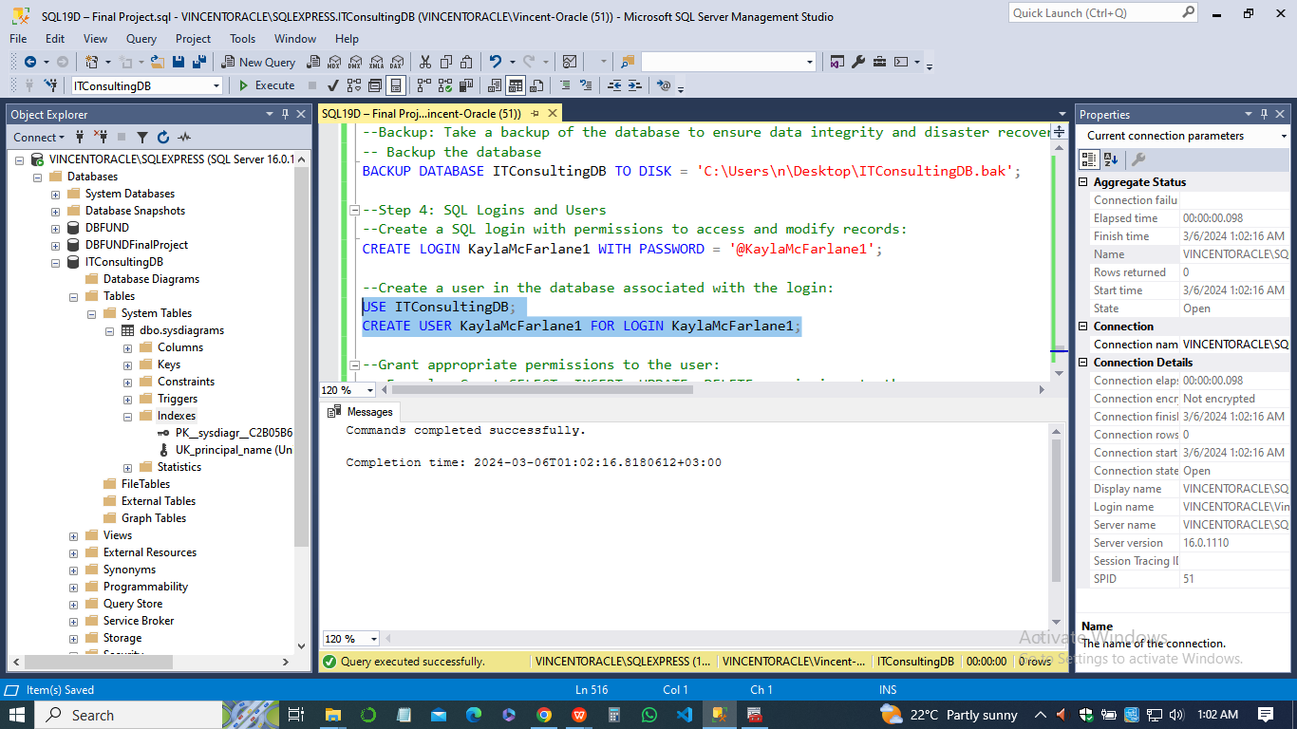

1. ***Grant appropriate permissions to the user***

Example: Grant SELECT, INSERT, UPDATE, DELETE permissions to the user

GRANT SELECT, INSERT, UPDATE, DELETE ON EquipmentTypes TO KaylaMcFarlane1;

1. ***Create a SQL login with read-only access***

CREATE LOGIN KaylaMcFarlane2 WITH PASSWORD = '@KaylaMcFarlane2';

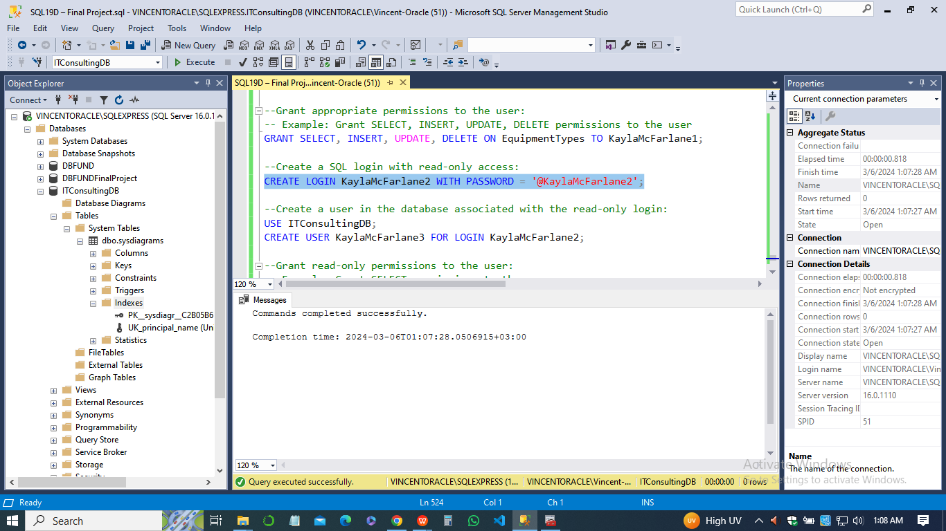

1. ***Create a user in the database associated with the read-only login***

USE ITConsultingDB;

CREATE USER KaylaMcFarlane3 FOR LOGIN KaylaMcFarlane2;

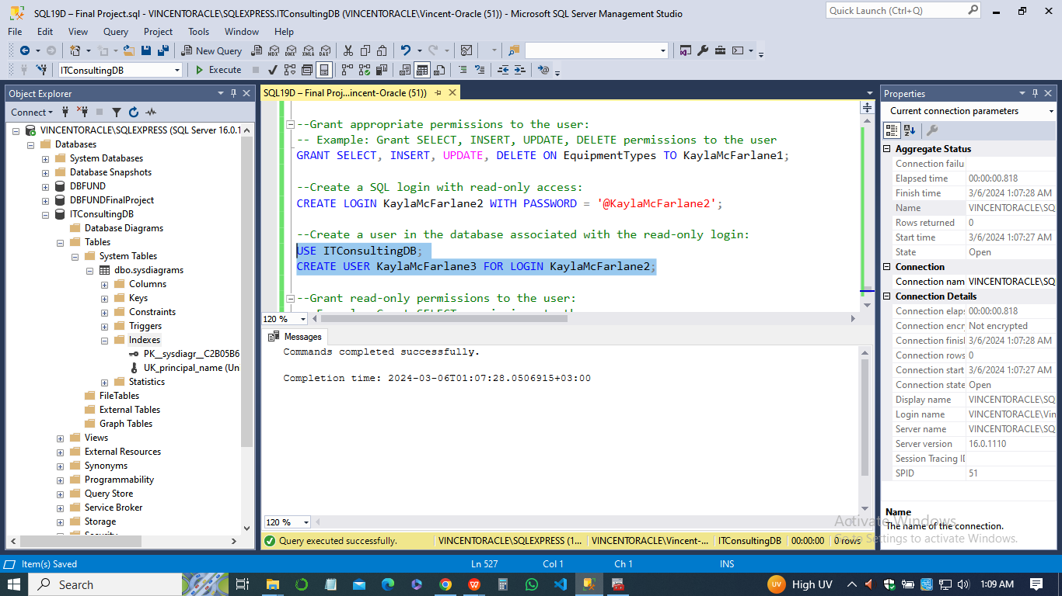

1. ***Grant read-only permissions to the user***

Example: Grant SELECT permissions to the user

GRANT SELECT ON Services TO KaylaMcFarlane3;

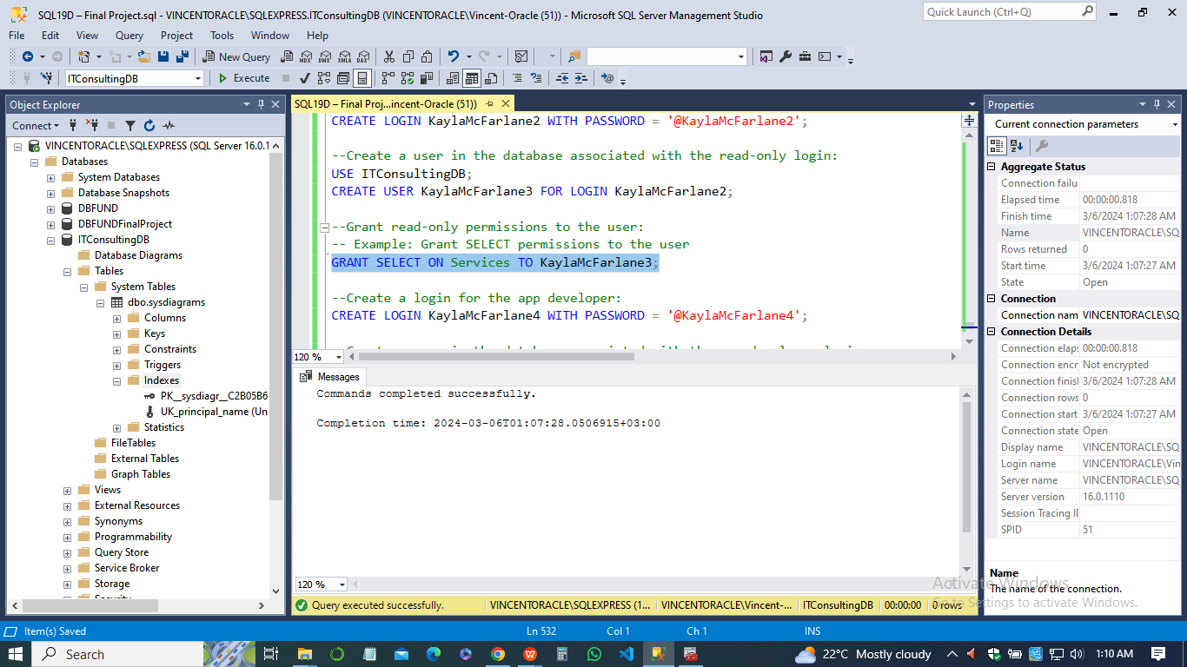

***Create a login for the app developer***

CREATE LOGIN KaylaMcFarlane4 WITH PASSWORD = '@KaylaMcFarlane4';

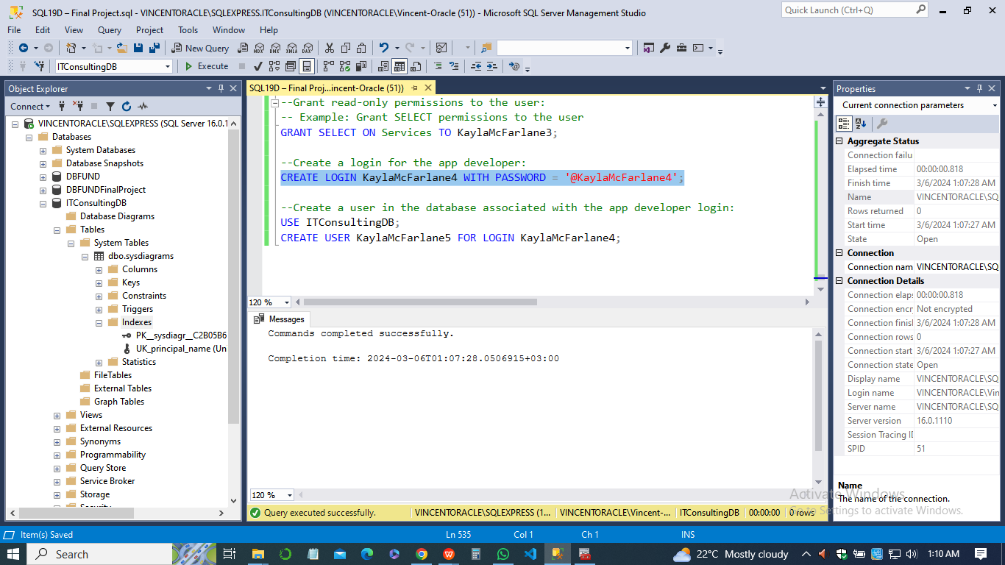

1. ***Create a user in the database associated with the app developer login***

USE ITConsultingDB;

CREATE USER KaylaMcFarlane5 FOR LOGIN KaylaMcFarlane4;

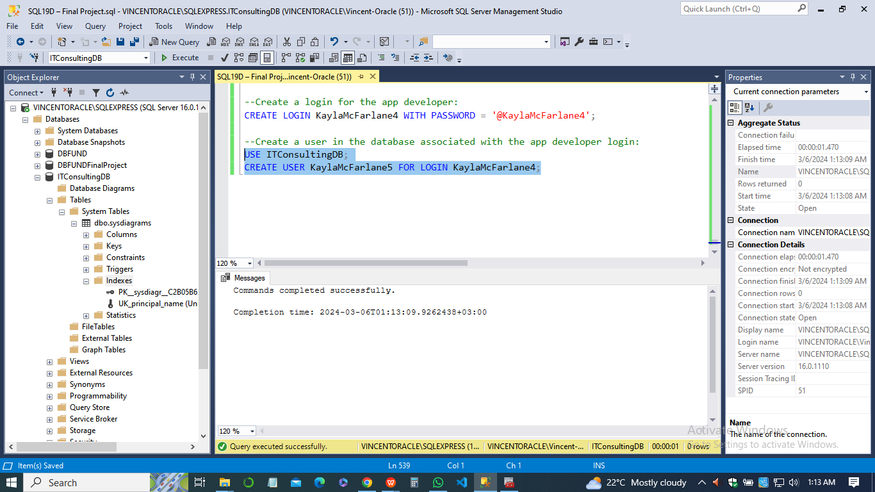

**Step 5: Performance Monitoring and Optimization**

1. Configured performance monitoring tools to isolate performance issues.
2. Established ongoing monitoring of SQL performance and usage.
3. Implemented optimization techniques to enhance database performance.
4. Scheduled regular database consistency checks to ensure data integrity.
5. Set up automated database backups for disaster recovery.
6. Configured email notifications to alert about any performance or integrity issues, with notifications sent to Kayla.McFarlene@triosstudent.com.

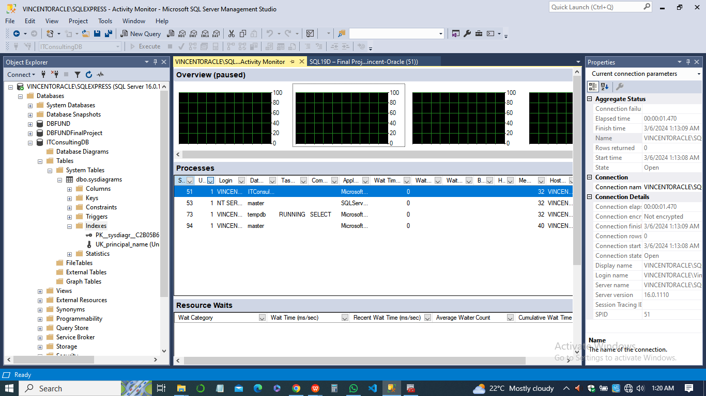

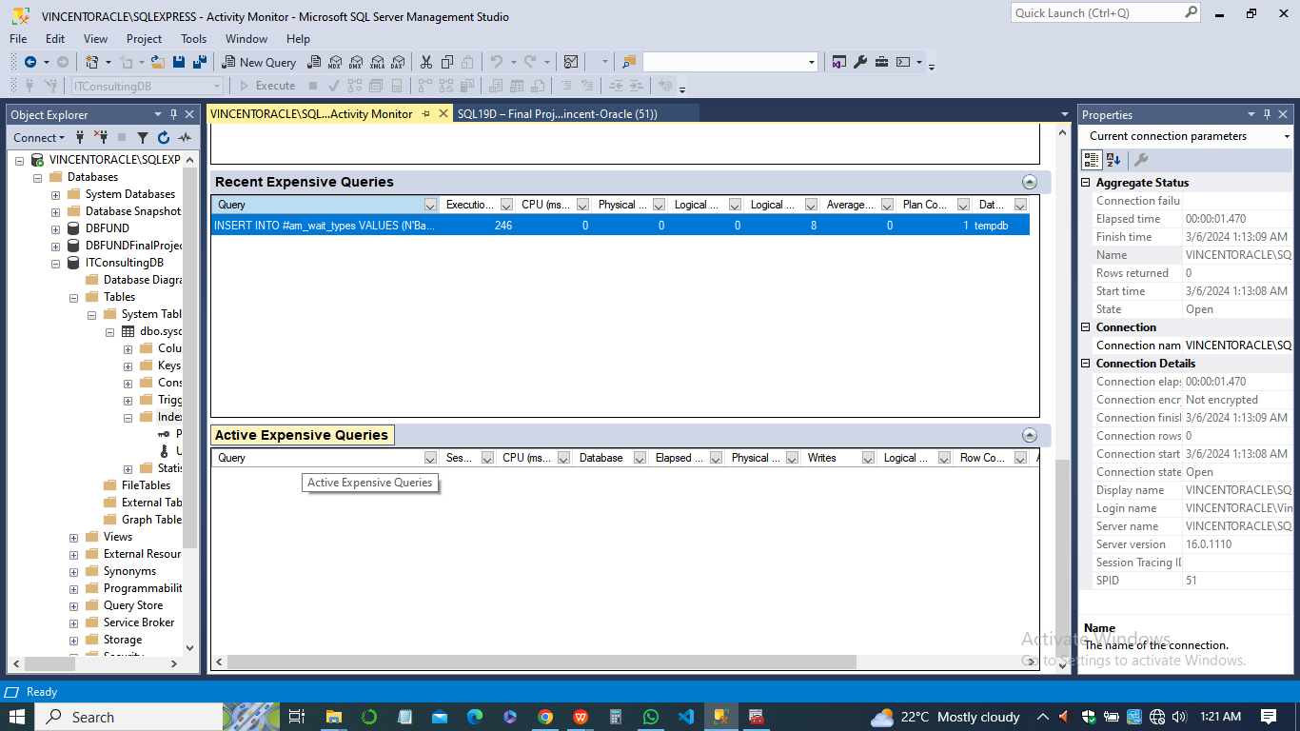

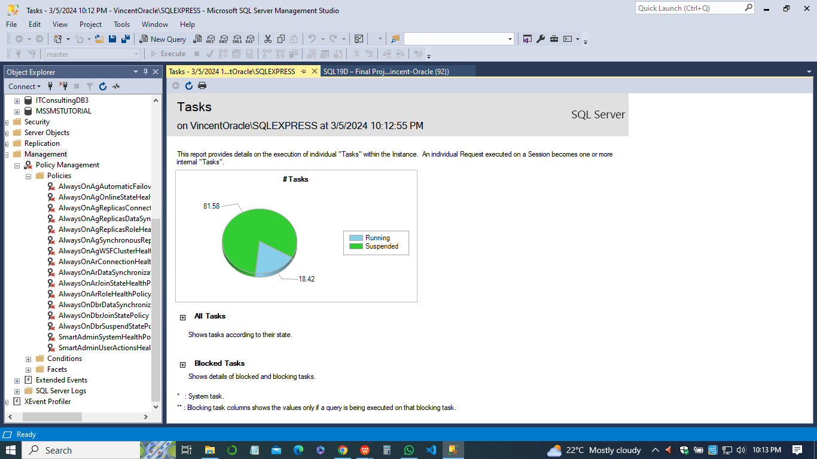

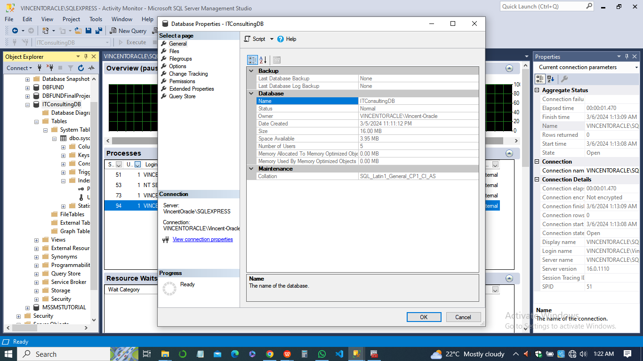

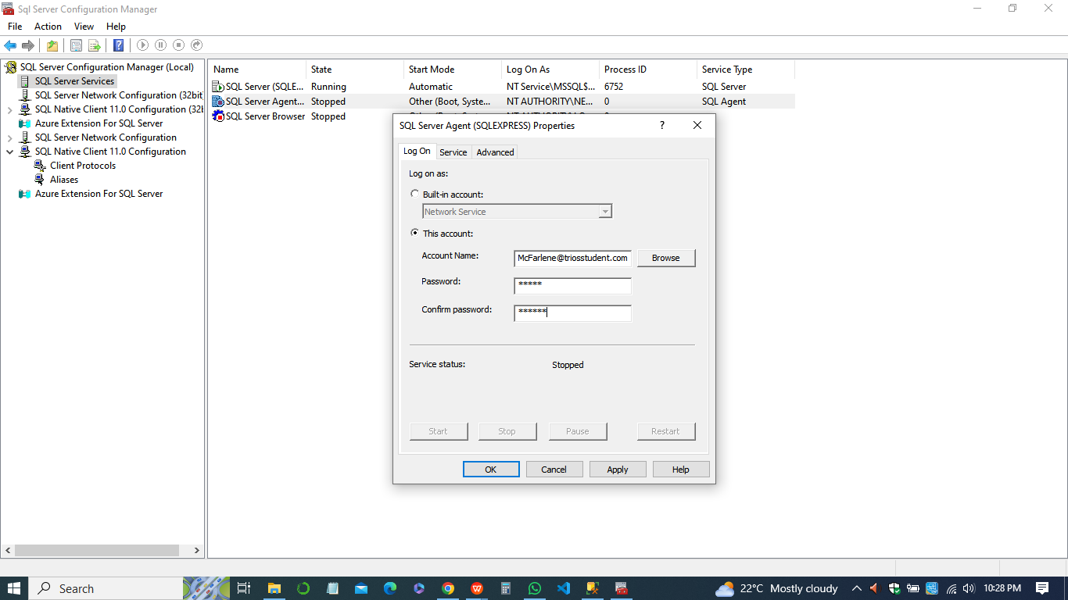

**Step 6: Fault Tolerance**

1. Implemented fault tolerance measures to ensure high availability and reliability of the database.
2. Configured database mirroring or clustering to provide failover support in case of server failure.
3. Established redundant storage solutions to prevent data loss in case of disk failure.
4. Tested failover mechanisms to ensure they function as expected during system disruptions.

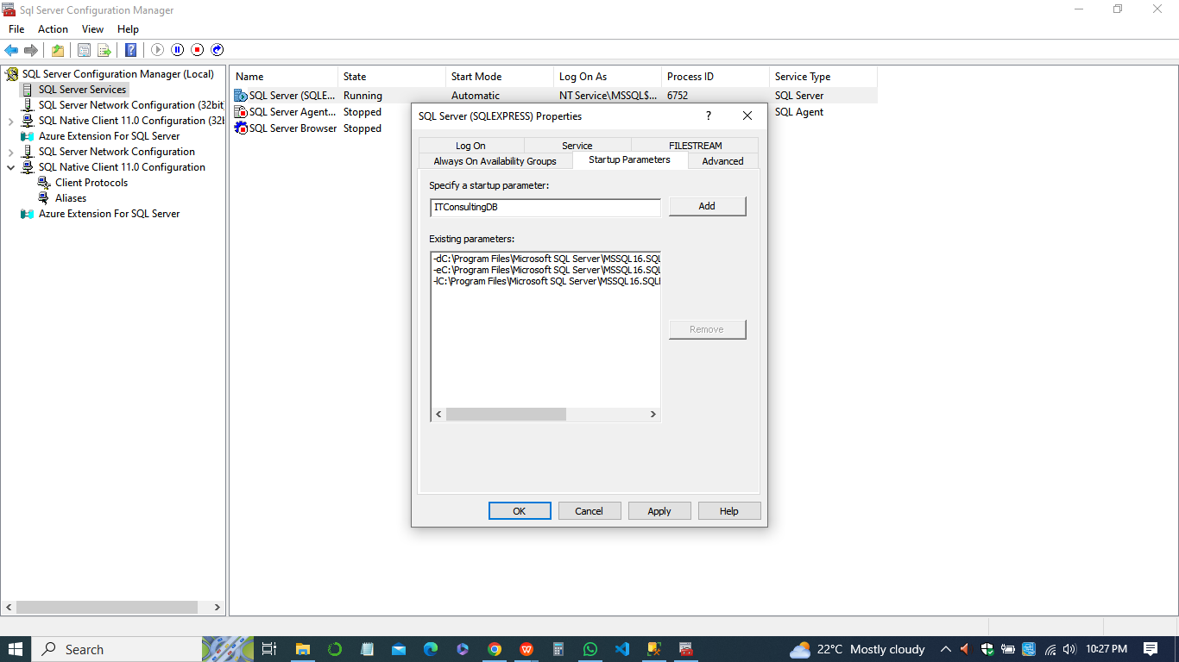

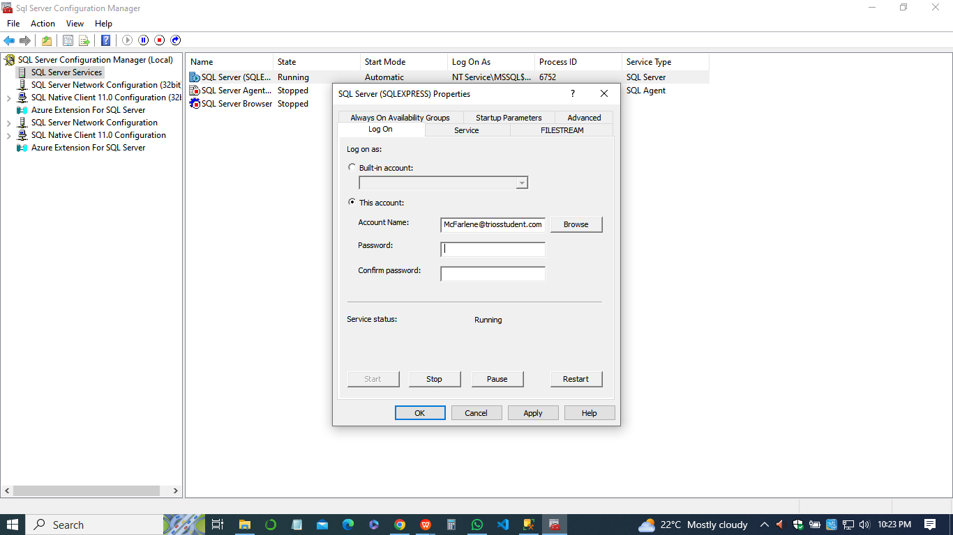

**Step 9: Optional Bonus**

1. ***The design***

The optional bonus involves designing a new database that serves as a data warehouse for the IT consulting company's operational database. The purpose of this data warehouse is to facilitate business intelligence analysis by organizing and consolidating data from various sources for reporting and analysis purposes. In this context, the data warehouse schema comprises several dimensions and a fact table. 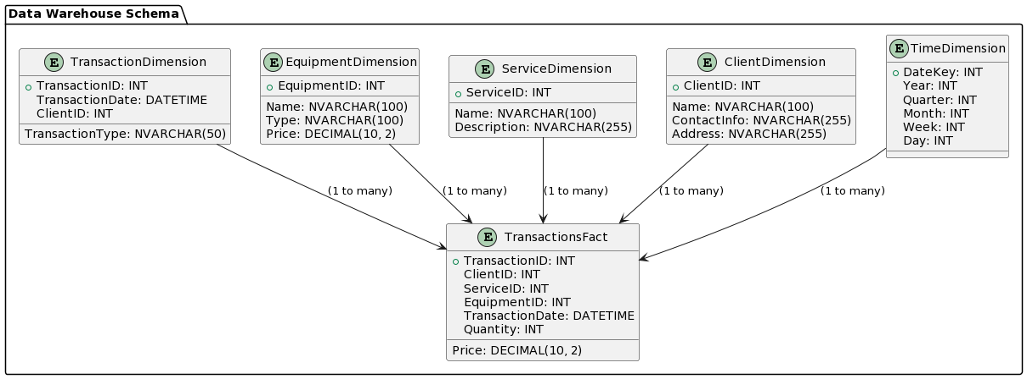

The dimensions represent different aspects of the business, such as time, clients, services, equipment, and transactions. Each dimension contains key attributes that provide context and detail for the data stored in the fact table. The fact table, on the other hand, serves as the central repository for transactional data. It captures information related to client transactions, including details about the services rendered, equipment used, transaction dates, quantities, and prices.

1. ***The new database that will be used as a data warehouse for IT Consulting Company***

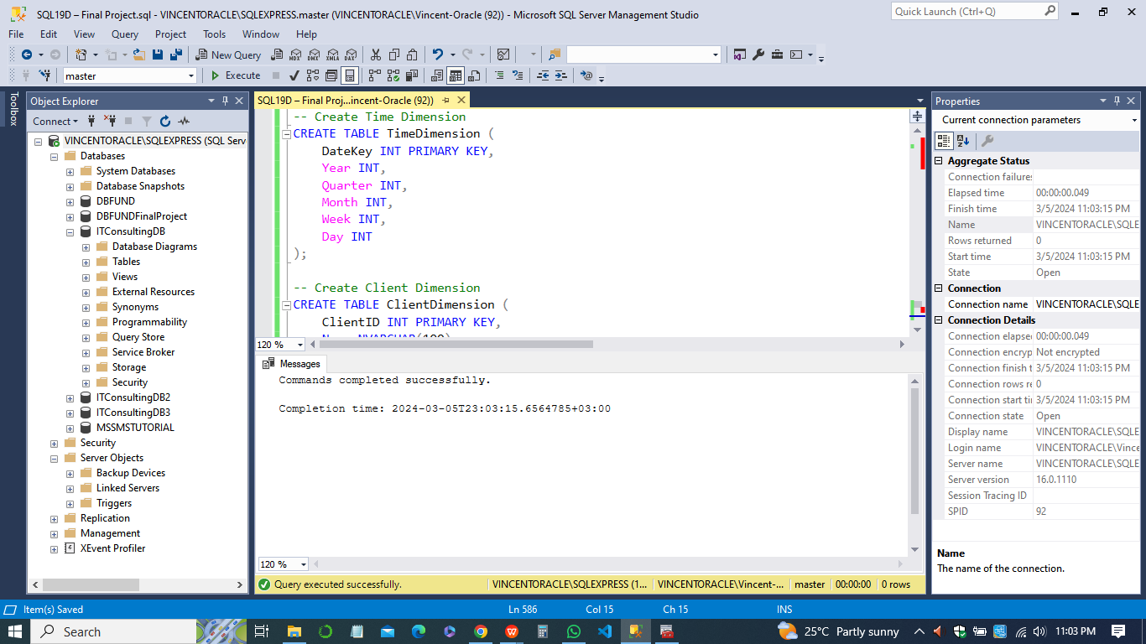

By structuring the data in this manner, the data warehouse enables analysts to perform complex queries and generate meaningful insights into various aspects of the company's operations. For example, analysts can analyze sales trends over time, assess the performance of different services or equipment types, and identify patterns in client behavior. In sum, the data warehouse provides a valuable resource for decision-makers within the organization, empowering them to make informed decisions based on comprehensive and accurate data analysis.